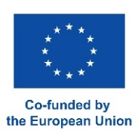

**eTwinning Seminar**

**“Innovation and Education”**

**15-17 May, 2023, Baku, Azerbaijan**

**(Draft Agenda)**

**15 may**

14:00-15:00 – Registration

15:00-15:30 – Welcome speeches by Ministry representatives

15:30-16:00 - Plenar session

16:00-16:30 - Coffee break

16:30-18:00 – Ice-breaking activities and partner finding

18:00 – Dinner

**16 may**

09:00-09:30 - Registration

09:30-11:00 – Parallel workshops

11:00-11:30 – Coffee break

11:30-13:00 – Parallel workshops

13:00-14.00 – Lunch

14:00-15:30 – Parallel workshops

15:30-16:00 – Coffee break

16:00-19:00 – City tour

19:00 – Gala Dinner

**17 may**

09:00-09:30 - Registration

09:30-10:30 – Panel discussion: Examples of good projects

10:30-11:00 – Coffee break

11:00-12:30 – Project registartion on the platform

12:30-13:00 – Closing of the seminar

13:00 – Lunch